Data Interpretation
Name: ______________________________
Date: ___________ Class: __________
Round One: Organize group members alphabetically by: ________________________________________

--
--
--
--
--
--
--
--
--
--
--

Round Two: Organize & Graph: _______________________________________
Variables: Independent-_________________ Dependent-________________

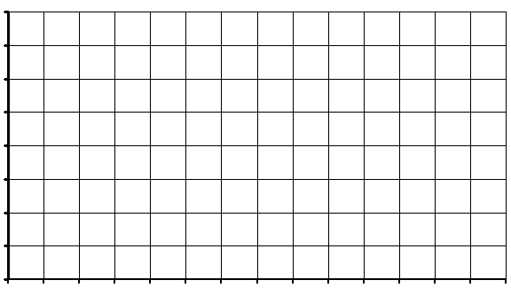

Round Three: Class Data
Variables: Independent-_________________ Dependent-________________

